**Title: Use of different SQL clauses and join**

**Objective:** To understand the use of group by and having clause and execute the SQL commands using JOIN

1.Consider the following schema:

**I/O- Student (sid, sname, age)**

**Match (mid, mname, venue)**

**Play (sid, mid, day(date))**

create table student (

sid int primary key,

sname varchar(20),

age int

);

create table Matches (

mid varchar(20) primary key,

mname varchar(50),

venue varchar(50)

);

create table play(

sid int, mid varchar(20),

pday date ,

primary key (sid,mid),

foreign key (sid) references student(sid),

foreign key (mid) references matches(mid)

);

1. Populate all the tables.

I/o- insert into student values

(1,'Amit',20),

(2,'Ajay',20),

(3,'Anu',19),

(4,'Ash',18);

INSERT INTO matches (mid, mname, venue) VALUES

('B10', 'ODI Final', 'Mumbai'),

('B11', 'Ranji', 'Delhi'),

('B12', 'Knights', 'Delhi'),

('B13', 'Knicks', 'Mumbai');

insert into play values

(1,'B10','2024-05-12'),

(2,'B10','2024-05-12'),

(2,'B11','2024-06-13'),

(3,'B11','2024-06-12'),

(3,'B12','2024-07-14'),

(4,'B13','2024-08-18'),

(4,'B12','2024-09-22');

Select * from student; 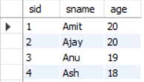

Select * from matches;

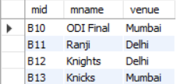

Select * from play; 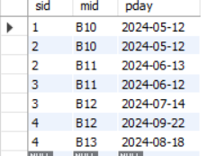

1. Find all information of students who have played match number B10.

I/O- Select * from student

Inner join play on student.sid=play.sid where(play.mid=’B10’)

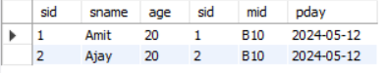

1. Find the name of matches played by Amit.

I/O-select mname from matches inner join play on matches.mid=play.mid where play.sid in (select sid from student where sname='Amit') ;



1. Find the names of students who have played a match in Delhi.

I/O- select sname from student s inner join play p on s.sid=p.sid where p.mid in (select mid from matches where venue = 'Delhi');

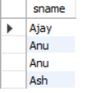

1. Find the names of students who have played at least one match.

I/O- select distinct sname from student s inner join play p on s.sid=p.sid ;



1. Find the ids and names of students who have played two different matches on the same day.
2. Find the ids of students who have played a match in Delhi or Mumbai.

select s.sid from student s inner join play p on s.sid=p.sid where p.mid in (select mid from matches where venue = 'Mumbai' or 'Delhi');

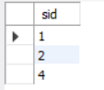

1. Find the average age of students.

Select avg(age) from student;

